Vermot-Desroches Matthias

Rapport de séance n°12

During this session, with a huge help from Mr. Masson, I finished to assemble the frame.

Here is how is looks:

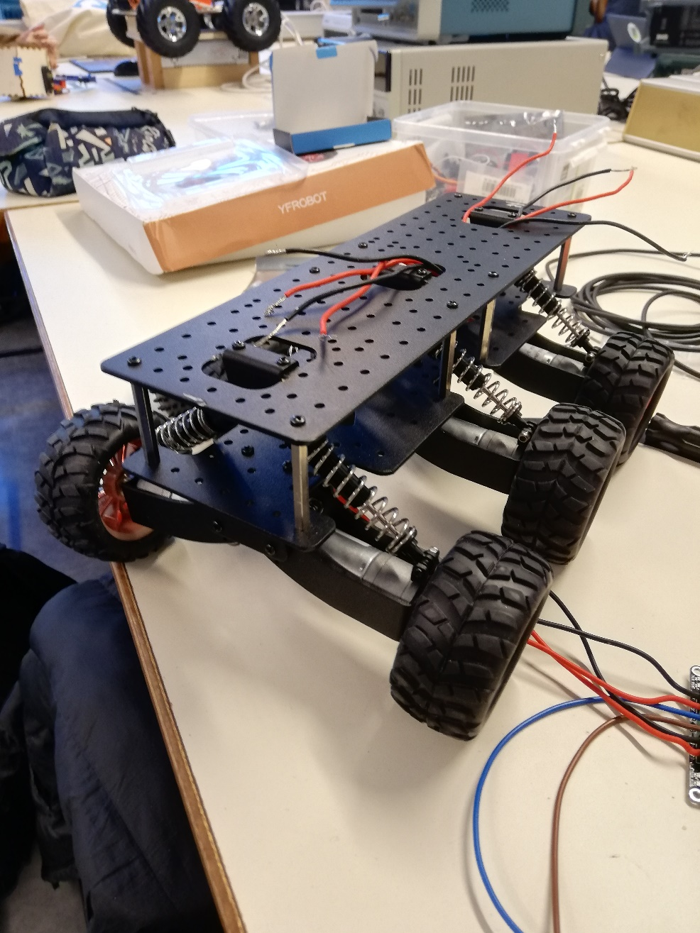

In order to achieve this result, we had to pierce and cut the upper part of the frame to allow the suspension’s support pieces to fit and resolve the issue found during the last session.  
  
I had an other issue with the nuts and screws, but I turned out that I could not screw them because I didn’t have the tools necessary to do it.

After that, I decided to try the program (to detect obstacle and turn accordingly with ultrasound sensors) I had made. This lead to a new issue: for some reason, the cable used to connect the motors and the alimentation kept melting, and the motors’ drivers also started to melt.

It took a long time before Mr. Masson and I fixed this by using another alimentation. We still don’t know why it occurred, the electrical link were right (no short-circuit possible), the motors and their drivers were new etc.

Then, I spent the remaining of the session modifying my program and trying it on 2 motors at the same time only.

Next time, I will try it on all the motors at the same time and it will hopefully work.